EXCEL AND SQL PROJECT

1. KPIs
2. Total Loan Applications

Select Count(id) as Total_Loan_Applications from bank_Loan



1. MTD Loan Applications

Select Count(id) as MTD_Total_Loan_Applications from bank_Loan where Month(issue_date)=12 and year(issue_date)=2021;



For MOM we have to calculate previous month loan disbursments too.

1. Total Funded Amount

select sum(loan_amount) as Total_Amount from bank_loan;

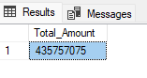

We have to find it for current month also.

1. Total amount Received

select sum(total_payment) as Total_Amount_Received from bank_loan;



We have to find it for current month also.

1. Average interest rate

select avg(int_rate) *100 as Average_Interest_Rate from bank_loan



We have to find it for the month also.

1. Average Debt to Income Ratio

select round(avg(dti),4) *100 as Average_DTI from bank_loan

DTH should be optimum.

1. Loan Status

select (count(case when loan_status = 'Fully Paid' or loan_status = 'Current' then id end )*100)/count(id) as Good_loan_percentage from bank_loan



1. No of good Loan applications

select count(id) from bank_loan where loan_status= 'Fully paid' or loan_status='Current'



1. Good Loan Funded Amount

select sum(loan_amount) as Good_Loan_Funded_Amount from bank_loan where loan_status= 'Fully paid' or loan_status='Current'



1. Good Loan Received Amount

select sum(total_payment) as Good_Loan_Received_Amount from bank_loan where loan_status= 'Fully paid' or loan_status='Current'



1. Bad Loan Percentage

select (count(case when loan_status = ‘Charged Off’ then id end )*100)/count(id) as Bad_loan_percentage from bank_loan



1. Number of Bad Loan Applications

select count(id) as Bad_Loan_appliactions from bank_loan where loan_status='Charged Off' ;



1. Bad Loan Funded Amount

select sum(loan_amount) as Bad_Loan_Funded_Amount from bank_loan where loan_status='Charged Off' ;



1. Bad Loan Received Amount

select sum(total_payment) as Bad_Loan_Received_Amount from bank_loan where loan_status='Charged Off' ;



1. Summary

select month(issue_date) as Month_number, datename(month, issue_date) as Month_, count(id) as Total_Loan_Applications, sum(loan_amount) as Total_Funded_Amount, sum(total_payment) as Total_Received_Amount from bank_loan group by month(issue_date), datename(month, issue_date) order by month(issue_date);

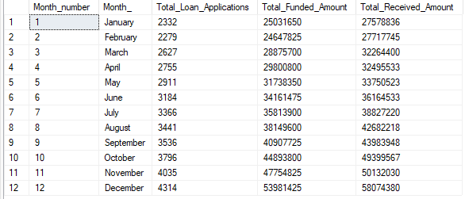

1. Summary

select address_state, count(id) as Total_Loan_Applications, sum(loan_amount) as Total_Funded_Amount, sum(total_payment) as Total_Received_Amount

from bank_loan group by address_state order by address_state;

1. Term Summary

select term, count(id) as Total_Loan_Applications, sum(loan_amount) as Total_Funded_Amount, sum(total_payment) as Total_Received_Amount

from bank_loan group by term order by term;

1. Summary employee tenure

select emp_length, count(id) as Total_Loan_Applications, sum(loan_amount) as Total_Funded_Amount, sum(total_payment) as Total_Received_Amount

from bank_loan group by emp_length order by emp_length;

1. Summary Purpose

select purpose, count(id) as Total_Loan_Applications, sum(loan_amount) as Total_Funded_Amount, sum(total_payment) as Total_Received_Amount

from bank_loan group by purpose order by purpose;

1. Summary Home Owner Ship

select home_ownership, count(id) as Total_Loan_Applications, sum(loan_amount) as Total_Funded_Amount, sum(total_payment) as Total_Received_Amount

from bank_loan group by home_ownership order by home_ownership;